Managing multi-stage kubernetes cluster

Kubeconfig.yaml

* Export KUBECONFIG=dev_airindia_kubeconfig.yaml …exporting to local
* Kubectl getnode …read cluster information
* Kubectl apply -f hotel.yaml …write action to the cluster

ETCD database holds the state of the information about cluster

Read command goes to APIserver which sends the request to ETCD that returns the information to APIserver

Kubectl enables you to access the cluster <https://docs.aws.amazon.com/eks/latest/userguide/create-kubeconfig.html>

Ways to create cluster: GUI, CLI, TERREAFORM

Helm is a tool to deploy jenkins, grafana, istio on K8S cluster

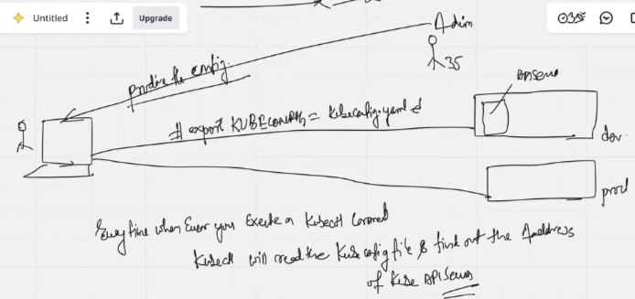

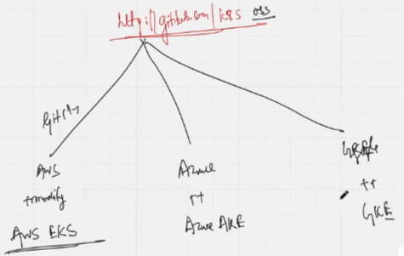

Github provides opensource kubernetes code that is available and is downloaded using "git clone" and made available by major players like AWS.

Difference between managed and non-managed K8S: 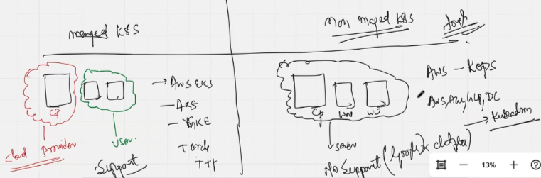

Release upgrades

<https://endoflife.date/kubernetes> → Kubernetes releases happen very frequently - always be on top as devops engineer.



Moving between releases → always upgrade to latest minor of the version coz minor-latest is the version of the release that has all the features of the release

AAA in kub-API server

Search Authentication, Authorization, Admission Control in chatgpt

What happen when I run kubectl apply -f hotel.yaml in chatgpt

How kube schedulers decide which POD will go on which particular node in chatgpt

How many PODs will be assigned to WorkerNode in chatgpt

How is POD and container different?

All the containers in a POD share the same IP with different port no.

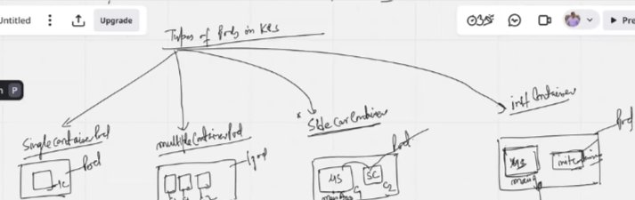

* Single container POD
* Multiple container POD
* Static container POD
* SideCar container POD - Run along main-C until runtime of main-C to export logs of main-C; uses=monitoring of main-C
* Init container POD - Pre-requisite tasks performed by init-C, runs and moves to complete the tasks then the main-C starts